# Course: web technnology

TOPIC:

LAWYER FARM SYSTEM

**ID:**

**NAMES:**

# Deployed Link for project: https://semi-rwanda.onrender.com/login?invalid

🡺To login as administrator your email must be belongs in this word “**admin1**”

Contents

Course: web technnology 1

Deployed Link for project: https://semi-rwanda.onrender.com/login?invalid 1

LAWYER FARM 3

1.1 Introduction 3

1.2 Ambition 4

1.3 Scope of the system 4

1.4 Entity relationship of the system 4

1.5 Design orgaisation of the system 5

Welcome page Login 7

SignUP Page 7

Admin home page 8

Registration page 9

View page 9

Page for search 9

# LAWYER FARM

## 1.1 Introduction

Welcome to law Firm system, where legal excellence takes root and grows. Just as a farm nurtures seeds into robust harvests, our firm cultivates the brightest legal talents, guiding them through a comprehensive and enriching development process. Here, we sow the seeds of knowledge, cultivate the skills of advocacy, and reap the rewards of a thriving legal community.

In our Farm System, we believe in more than just producing lawyers; we foster the growth of leaders, innovators, and ethical practitioners who will cultivate justice and uphold the principles of the legal profession. Our approach is holistic, ensuring that each member of our legal farm receives the personalized attention and training needed to blossom into a skilled and compassionate advocate.

Join us in the fertile grounds of legal education and professional development, where the seeds of potential become the pillars of success. our Farm System is not just a training ground; it's a community that nurtures legal minds, cultivates expertise, and harvests a legacy of legal excellence..

## 1.2 Ambition

The ambition of our lawyer farm is to sow the seeds of legal brilliance, nurturing a cadre of professionals who transcend mere competence. We aspire to cultivate leaders, instilling in our lawyers the qualities that drive positive change and innovation within the legal sphere. Ethical fortitude is the bedrock of our ambition, ensuring that our legal harvest upholds the highest standards of justice. We are committed to making a tangible impact on communities, fostering a global perspective that equips our lawyers to navigate an interconnected world. With an unwavering dedication to continuous learning, we aim to create a legacy not just of success, but of enduring influence on the legal landscape and society at large

## 1.3 Scope of the system

1. Helps people find and communicate with lawyers they want to work with
2. Gives advocacy and resources to provide evidence and track their clients' progress
3. Provides a library of self-help materials and other resources for clients and lawyers to use

## 

## 1.4 Entity relationship of the system

client

Signup

Contact us

Singup

Suggestion

On the system

1,n

1,n

1,n

1,n

## 1.5 Design orgaisation of the system

home

View case

search

Download report

message

logout

Welcome page

login

signup

Admin page

Client page

home

request

comment

logout

**Here are images of shows the structure of my project**

# Welcome page Login

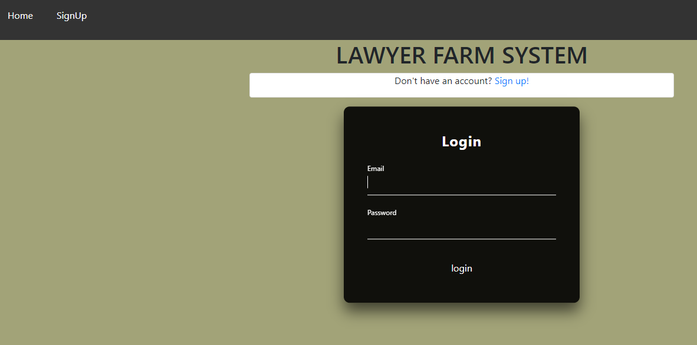

# SignUP Page

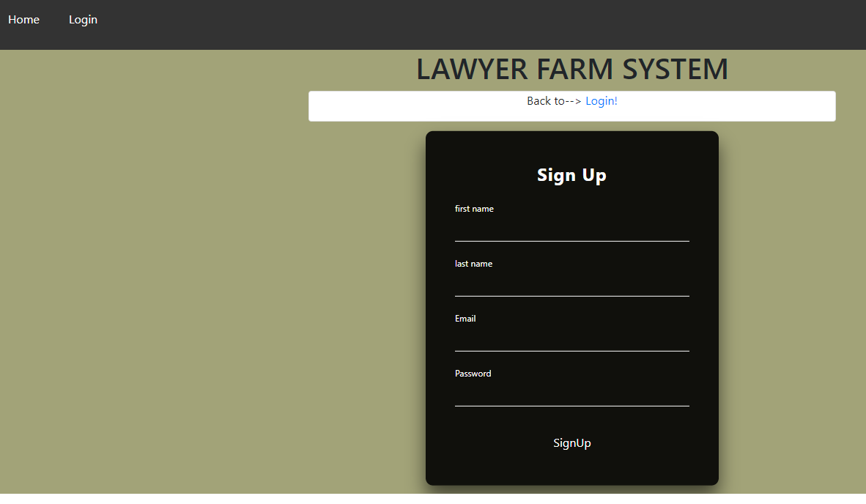

# Admin home page



# Registration page

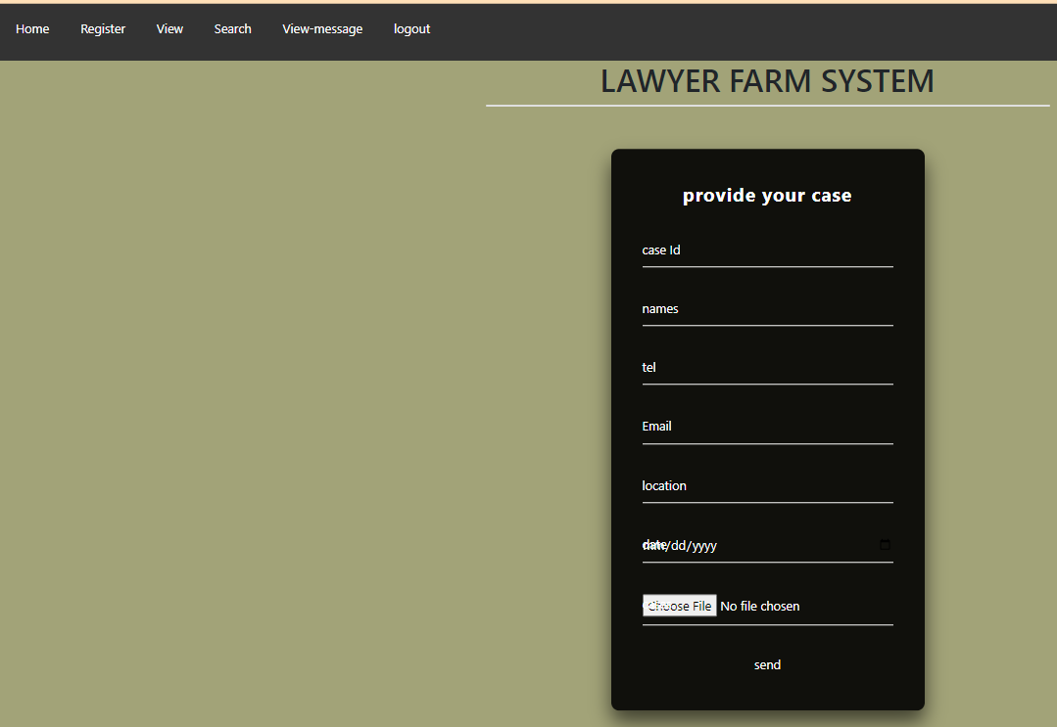

# View page

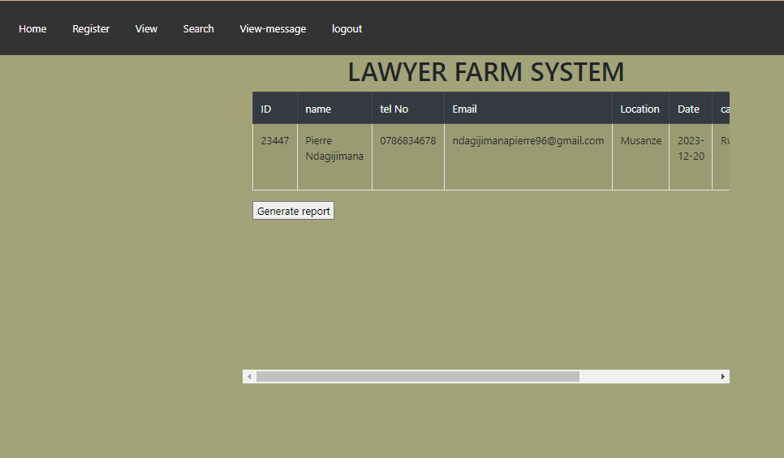

# Page for search

# 6b.PNG